**PROJECT SYNOPSIS**

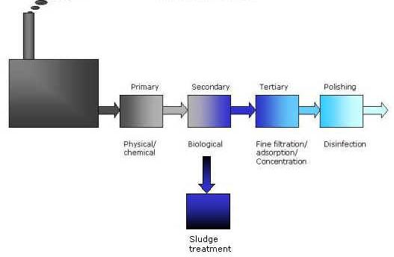

**Wastewater Treatment**

**An Innovative Design Based on the Working Principle of Wastewater Treatment and Its Application in Energy Production**

**BENGAL INSTITUTE OF TECHNOLOGY**

PINAKI CHANDRA DEY

SRIJEET BANERJEE

RAJDEEP PAUL

ARJAN SAHA

|  |  |
| --- | --- |
| NAME OF THE PROJECT | WASTEWATER TREATMENT |
| VISION OF THE PROJECT | The Project Will Constituting an Innovative Design Based on the Working Principle of Wastewater Treatment and Its Application in Energy Production. |
| FUNCTIONAL SPECIFICATION | * This project aims at developing a highly cost-effective wastewater treatment plant which would cater the needs of the people intending to employ treatment of waste water in a medium scale. * The device & associated accessories will use non-polluting natural resources and hence will be eco-friendly. * More over the system will generate electricity which could be utilized as the seed of the system or even be stored in a capacitor. * There is also a scope of production of oxygen which would be beneficial for environment further proving its eco-friendly nature. * The treated water is expected to be rich in purity and devoid of any contaminants and carcinogenic materials. * Results suggest that the BOD of the treated water is within the permissible range of BOD of drinking water. * After passing the BOD test the water may be further oxygenated to make the quality richer. * The device will be easily customizable to enhance its functionality further at any future time as per requirements & available resources. * The system will be easy to operate. * The working principle of the system has been successfully tested. |
| TECHNICAL SPECIFICATION | Wastewater treatment is the process of removing contaminants from wastewater and household sewage, both runoff (effluents) and domestic.  It includes physical, chemical and biological processes to remove physical, chemical and biological contaminants.  Its objective is to produce pure drinking water or just a treated effluent and a solid waste or sludge suitable for discharge or reuse back into the environment.  The Overall Process of Wastewater Treatment in our System is as follows:  1. Origins of sewage  2. Process overview  2.1 Primary treatment  2.1.1 Screening  2.1.2 Sedimentation  2.2 Secondary treatment  2.2.1 Activated sludge  2.2.2 Surface-aerated basins  2.2.3 Filter beds/oxidizing beds  2.2.4 Biological aerated filters  2.2.5 Membrane bioreactors  2.2.6 Secondary sedimentation  2.2.7 Rotating biological contactors  2.3 Tertiary treatment  2.3.1 Filtration  2.3.2 Lagooning  2.3.3 Constructed wetlands  2.3.4 Nutrient removal  2.3.4.1 N2 removal  2.3.4.2 PO42- removal  2.4 Disinfection  2.4.1 Chlorination  2.4.2 UV Disinfection  3. Batch reactors  4. Oxygen Production & Electricity Generation  5. Sludge treatment and disposal  5.1 Anaerobic digestion  5.2 Aerobic digestion  5.3 Composting  5.4 Sludge disposal  6. Treatment in the receiving environment |
| Anticipated outcome & usefulness of the project | * Treated water, suitable for drinking and rich in quality. * Eco-friendly Perspective. * Easy to Operate and Maintain. |
| ECONOMIC ASPECT OF THE PROJECT | * Highly Economical System. * Lesser Power Consumption. * Energy Recycling. * Low Production Costs. |
| Project leader | RAJDEEP PAUL |
| Project developers | PINAKI CHANDRA DEY  SRIJEET BANERJEE  ARJAN SAHA |
| Contact details | PINAKI CHANDRA DEY🡪9874968732  SRIJEET BANERJEE🡪9830368564  RAJDEEP PAUL🡪 9903861217  ARJAN SAHA🡪9836564673 |
| Project guidance |  |
| Project accommodation & courtesy | BENGAL INSTITUTE OF TECHNOLOGY,  DEPARTMENT OF BIOTECHNOLOGY |

Signature of Project Leader: __________________________________________

Signature of Project Developers:__________________________________________

__________________________________________

__________________________________________

Date: ______________________

Approval of Project Guide: __________________________________________

Date: ______________________

**P.S. This is only a specimen of a Project Synopsis. You may change the subject of the synopsis at your will. Only the important & necessary points are depicted here.**